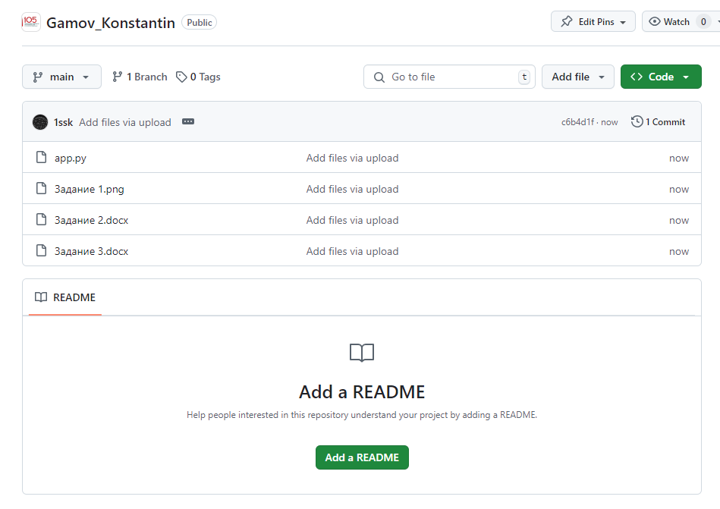



https://github.com/Group-218/Gamov_Konstantin